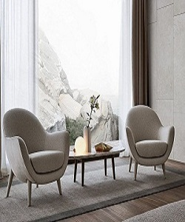

Upholstered fabric arm chair with arm rests.

$98.03

Availability: In stock

### Description

Armchairs are with large, soft dimensions, lightened by slender feet. They have a big personality and a striking decorative presence.‎ the expression of aesthetic and functional research that ensures an increasingly complete solution for interpreting contemporary living.‎